The Houston Museum of Natural Science

Wiess Energy Hall
Knowledge Hunt
6th – 8th Grade

Thank you for downloading the free online curriculum available at HMNS. We are thrilled that you include the world-renowned Houston Museum of Natural Science in your educational toolkit.
Here at HMNS, our mission has always been to provide exemplary educational opportunities for the community. Providing educators like you with a free, fully editable curriculum is just one of many ways we are fulfilling that mission.
Thank you again, and we hope you enjoy your field trip to HMNS!

How to use this guide:

- Feel free to edit the questions to suit your student group.
- The Knowledge Hunt is specifically for the Wiess Energy Hall.
- Visitor services and security staff are posted around the Museum and will be happy to assist you in finding any of the locations or objects mentioned.
- Please ensure that one chaperone is with every group of ten students at all times as they complete these activities.
For high school curriculum, please contact curriculum@hmns.org

Vocabulary
energy, sedimentary, electricity, hydrocarbons, reservoirs, geologist, explorations, subsurface, seismic, borehole, molecule, consumer, nuclear, hydroelectric, conductor, current, generators, turbine, alternative, deplete, non-renewable, renewable, conservation

Knowledge Hunt

Instructions: As you enter the Wiess Energy Hall, you will start at the Formation Video and work your way through the exhibits.

Introduction
Energy is a part of everything we do! In today’s world, the petrochemical industry has become integrated into almost every aspect of life: transportation, food preparation, electricity, medicines, plastics, and much more. In the Wiess Energy hall, you will learn how oil is formed inside the earth and the drilling and refining process that allows us to use it daily.
As you tour the Wiess Energy Hall, complete the chart with examples of renewable, nonrenewable, and alternative fuel sources.
Renewable | Nonrenewable | Alternative

Fill in the correct words with the definitions below the chart: Alternative, Renewable, Nonrenewable
_____________________________ is an energy source that can be replaced or replenished.
_____________________________ is an energy source that cannot be replaced or replenished.
____________________________ is an energy source other than a fossil fuel.

Formation
The movie states there was “a super thermal radiation of unimaginable scale.” What is this theory called?

What is the origin of all energy on Earth?

Plate Tectonics
The Earth is constantly changing on a scale that challenges our everyday notion of time. The continental plates that have been shifting for the last 600 million years continue moving tiny distances daily. The North American Plate you are standing on is moving about an inch west yearly!
Locate the plate tectonics interactive screen. Slid the bar slowly. What is happening to the continental plates over time?

Slide the bar to 200 million years ago. Sketch what you see below.

Trapping Structures & Migration of Hydrocarbons
Different rock layers form complex underground shapes as they move and change over millions of years. When the layers line up just right, they can trap oil and natural gas beneath them. Geologists classify these traps by how they form.
List three different kinds of traps:
.
.
.

Layer Cake Geology
Complete the following geology equation
Heat + pressure = __________________

Marine Microorganisms Overhead Sculptures
The floating forms above are highly enlarged replicas of fossils of microorganisms, similar to the fossils that geologists study in rock layers. These creatures lived in the oceans millions of years ago. Since different creatures live at various times and in different environments, geologists can use them as markers to determine the age of the rock and the conditions present during its formation.
Oil and natural gas are created when the remains of similar creatures and other organic material transform chemically over time into _______________________.
Draw a simple sketch of one of the microorganisms below.

Global Hydrocarbon Information Center
Most of the world’s hydrocarbons are concentrated in sedimentary basins created by tectonic activity. However, these regions are not always in the areas of highest demand for oil and natural gas; thus, the energy industry is an international affair. As we deplete the easily accessible reserves, our hydrocarbon production will adapt to meet the demand for energy-dense fuels. Explore the interactive map to see where the world’s hydrocarbon reserves are distributed.

Where are the world’s major oil and natural gas fields located? Mark them on the map.
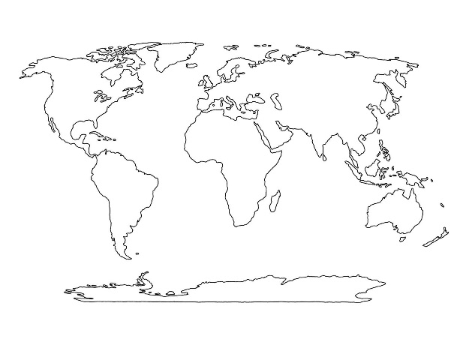
Thermal Imaging Cameras
Geoscientists often view the earth with sensors that can reveal much more than the human eye can see. The camera sees invisible infrared radiation rather than visible light. The colors in the image represent surface temperatures resulting from different amounts of infrared radiation.
Step in front of the camera. What colors do you see?
Explain what the different colors indicate about you.

Why do geologists use these cameras?

Exploration Field Geology (Video Diorama)
Geologists examine surface topography and geology and, if possible, inspect rock samples from nearby wells. Geophysicists conduct surveys to produce a better picture of the rock that lies below.
Press the button and watch
How do geologists decide where to drill for oil or gas?

What is the only way to confirm the presence of oil or natural gas in an underground formation?

Name three professions that work together to figure out how to get to the oil and gas beneath the surface.
1.
2.
3.
Seismic Imagery
The image on this wall is a computer-generated picture of underground rock layers created by reflected sound waves, known as seismic waves. The green and gold bands indicate rock layers with differing sound velocities and densities.
What is the large bluish-white structure?

Why do geologists study images like this?

Describe the bright spots and how they are indicated in this image.

Keep in mind that drilling through salt destroys your drill bit. Find a location on the seismic section that would be the best place to drill for oil. Draw the section you choose and explain your answer.

Drill Bits
The drill bit is the tool that makes a hole in the rock to reach deep underground. Different drill bits have been developed to work best in various rock types. There are two main classes of drill bits: roller cone and fixed-cutter. Bit diameters range from less than four inches to more than thirty, and the materials used to make them range from hardened steel to industrial diamond inserts.

Locate the tri-cone insert bit. How many roller cones does it have?

Locate the Hughes Simplex Dual Cone bit. Observe the differences between it and the tri-cone insert bit. Which do you think was more effective at drilling? Why?

How many similar roller cones are found on the tri-cone insert bit?

Reservoir and Production
Not all reservoirs are naturally pressurized. At some point, the oil must be lifted out. Most oil and natural gas wells in the U.S. require some means of artificial lift.

What is the most common type of artificial lift?

Explain how a standard artificial lift works.

Geovator
Why does limestone make an excellent reservoir rock for oil and natural gas?

How is sandstone formed?

Power Generation Turbine
This is a gas turbine engine. It spins at 15,000 rpm at full load and can produce 5.6 megawatts of electrical power. The compressor draws air into the inlet (suck). The rotating blades of the compressor and the interior geometry of the turbine compress the air before it enters the combustion chamber (squeeze). When fuel is burned with the compressed air (bang), the expanding gas drives a turbine (blow) that turns the rotor of a generator, inducing electrical current.
Watch the video “How a Generator Works”. Write a short paragraph describing how a generator works using a step-by-step process.

Electricity is the constant flow of ________________________.
Coal Power
Coal power has fueled revolutions in human history. With the versatile steam engine, we harnessed this powerful, widely available energy source back in the early 18th century, and since then, it has contributed to the exponential growth of our technology and population.

List two specific problems associated with coal use.

List what possible measures can be taken to lessen the impact of coal use on the environment. Which one do you think would work best? Explain your reasoning for picking one over the others.

Energy City
Energy City is a 2,800-square-foot diorama brought to life with projected animation. It depicts a version of the Texas Gulf Coast near Houston. The vast landscape includes the city skyline and ship channel, offshore Gulf of Mexico, and inland areas. The animation shows the varieties of energy that power the city. Watch Energy City for a while and see the constant changes.
List the types of alternative energies you can locate in Energy City.

Choose two alternative energy sources and describe which has the most significant economic and environmental impact. Use at least three reasons in your argument.

